ADVANCE MYSQL FOR INTERNET MOVIE DATABASE

==1.Count the total number of records in each table of the database.
SELECT 'MOVIE'AS TABLE_NAME, COUNT(*)AS ROW_COUNT FROM MOVIE
UNION ALL
SELECT 'GENRE'AS TABLE_NAME,
COUNT(*)AS ROW_COUNT FROM GENRE
UNION ALL
SELECT 'DIRECTOR MAPPING'AS TABLE_NAME,
COUNT(*)AS ROW_COUNT FROM DIRECTOR_MAPPING
UNION ALL
SELECT 'ROLE MAPPING'AS TABLE_NAME,
COUNT(*)AS ROW_COUNT FROM ROLE_MAPPING
UNION ALLSELECT 'NAMES'AS TABLE_NAME,
COUNT(*)AS ROW_COUNT FROM NAMES
UNION ALL
SELECT 'RATINGS'AS TABLE_NAME,
COUNT(*)AS ROW_COUNT FROM RATINGS;

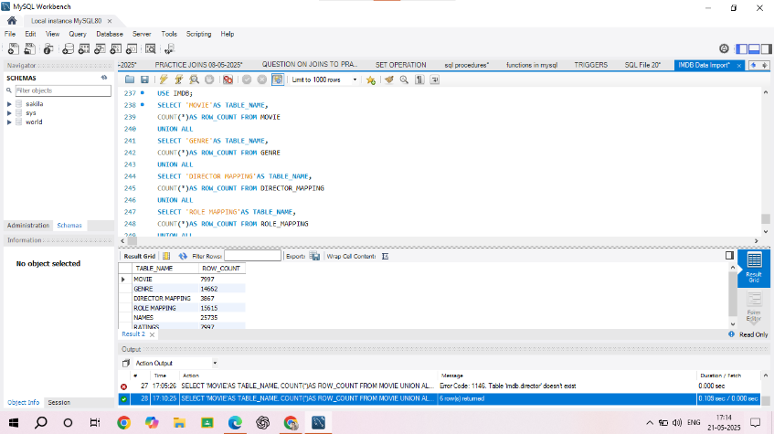
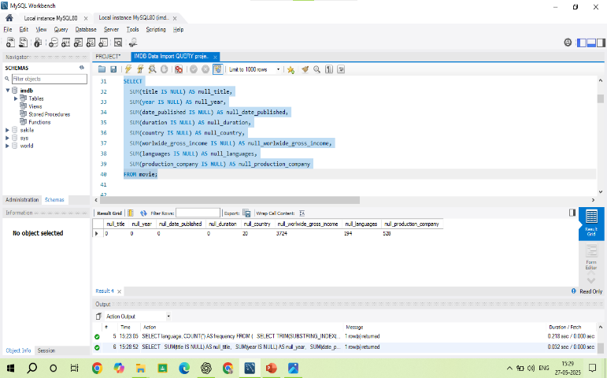

==2. Identify which columns in the movie table contain null values.
SELECT
SUM(title IS NULL) AS null_title,
SUM(year IS NULL) AS null_year,
SUM(date_published IS NULL) AS null_date_published,
SUM(duration IS NULL) AS null_duration,
SUM(country IS NULL) AS null_country,
SUM(worlwide_gross_income IS NULL) AS null_worlwide_gross_income,
SUM(languages IS NULL) AS null_languages,
SUM(production_company IS NULL) AS null_production_company
FROM movie;
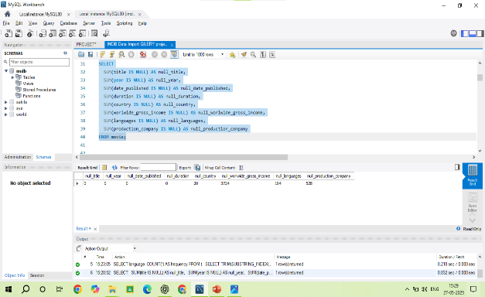
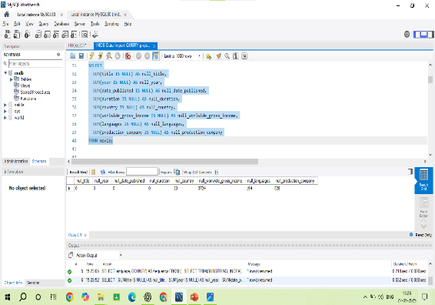
--3.Determine the total number of movies released each year, and analyze how the trend changes
month-wise.
SELECT year, COUNT(*) AS total_movies
FROM movie
GROUP BY year;

-- Month-wise trend per year
SELECT
YEAR(date_published) AS release_year,
MONTH(date_published) AS release_month,
COUNT(*) AS movie_count
FROM movie
GROUP BY release_year, release_month
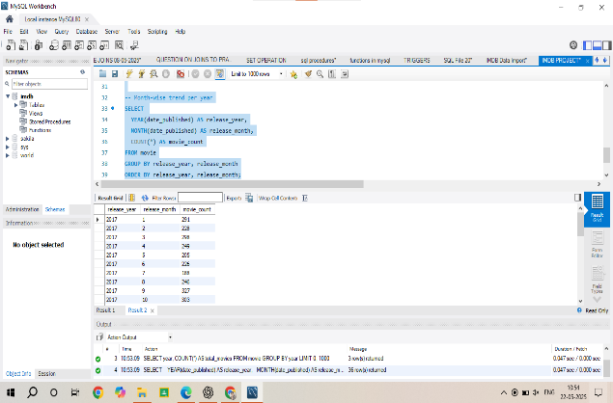
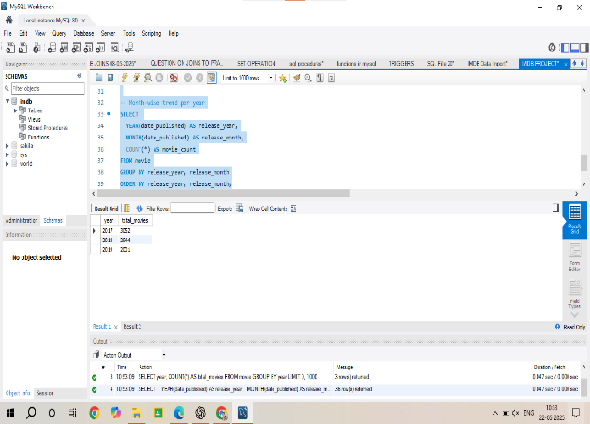
ORDER BY release_year, release_month;

--4.How many movies were produced in either the USA or India in the year 2019?
SELECT COUNT(*) AS MOVIE_produced
FROM movie
WHERE country IN ('USA', 'India') AND year = 2019;
SELECT country, COUNT(*) AS MOVIE_produced
FROM movie
WHERE country IN ('USA', 'India') AND year = 2019
GROUP BY COUNTRY;
SELECT YEAR, COUNT(*) AS MOVIE_produced
FROM movie
WHERE country IN ('USA','INDIA') AND year = 2019
GROUP BY YEAR;

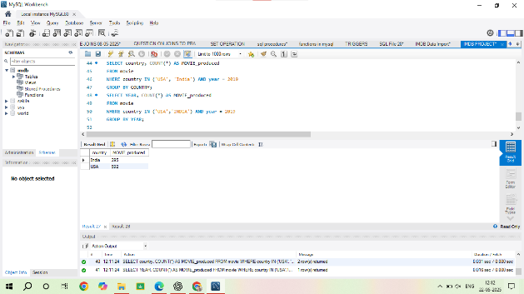
--5 List the unique genres in the dataset, and count how many movies belong exclusively to one
genre.
SELECT DISTINCT genre
FROM genre;
SELECT COUNT(*) AS single_genre_movie_countFROM (
SELECT movie_id
FROM genre
GROUP BY movie_id
HAVING COUNT(*) = 1
) AS single_genre_movie;
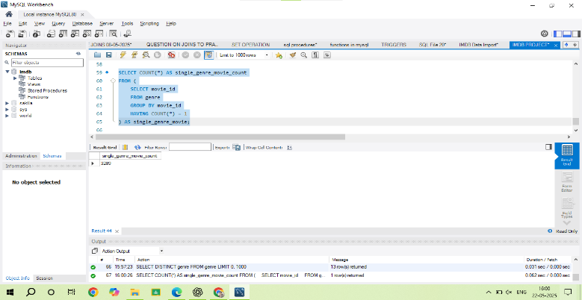
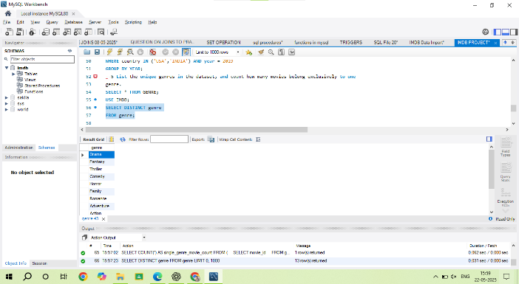

--6. Which genre has the highest total number of movies produced?
SELECT COUNT(*)MOVIES_PRODUCED
FROM GENRE;
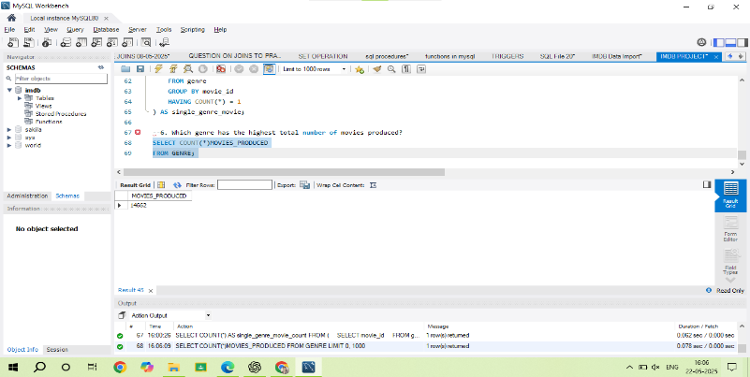
SELECT COUNT(MOVIE) as highest_total FROM genre;

--7. Calculate the average movie duration for each genre.
use imdb;
SELECT AVG(duration) FROM movie;
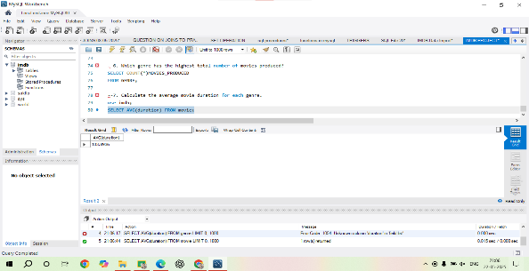
---8. Identify actors or actresses who have appeared in more than three movies with an average
rating below 5.
use imdb;
SELECT n.id, n.name
FROM names n
JOIN role_mapping rm ON n.id = rm.name_id
JOIN ratings r ON rm.movie_id = r.movie_id
WHERE r.avg_rating < 5
GROUP BY n.id, n.name
HAVING COUNT(DISTINCT rm.movie_id) > 3;
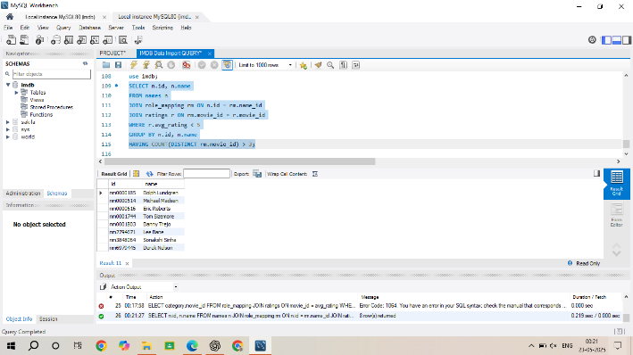

==9. Find the minimum and maximum values for each column in the ratings table, excluding the
movie_id column.
SELECT
MIN(avg_rating) AS min_avg_rating,
MAX(avg_rating) AS max_avg_rating,
MIN(total_votes) AS min_total_votes,
MAX(total_votes) AS max_total_votes,
MIN(median_rating) AS min_median_rating,
MAX(median_rating) AS max_median_rating
FROM ratings;
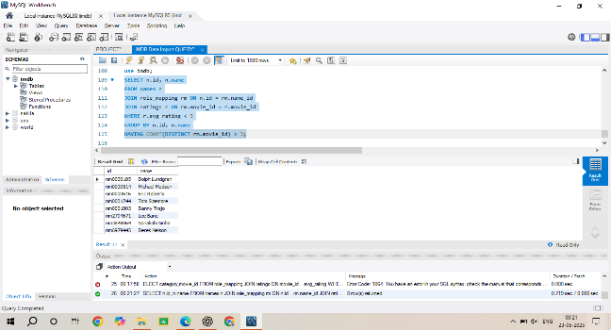
==10. Which are the top 10 movies based on their average rating?
SELECT m.id, m.title, r.avg_rating
FROM movie m
JOIN ratings r ON m.id = r.movie_id
ORDER BY r.avg_rating DESC
LIMIT 10;

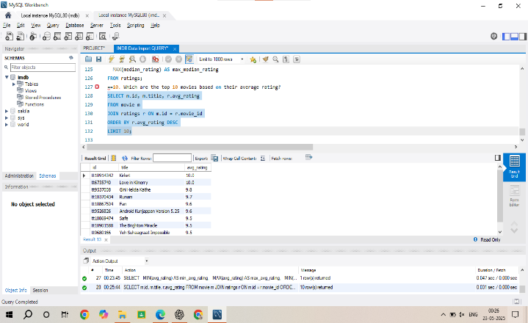
==11. Summarize the ratings table by grouping movies based on their median ratings.
SELECT median_rating, COUNT(*) AS movie_count
FROM ratings
GROUP BY median_rating
ORDER BY median_rating;
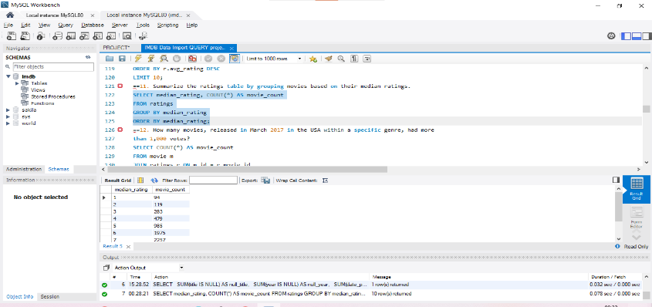
==12. How many movies, released in March 2017 in the USA within a specific genre, had more
than 1,000 votes?
SELECT COUNT(*) AS movie_count
FROM movie m
JOIN ratings r ON m.id = r.movie_id
JOIN genre g ON m.id = g.movie_id
WHERE MONTH(m.date_published) = 3
AND YEAR(m.date_published) = 2017
AND m.country LIKE '%USA%'
AND r.total_votes > 1000
AND g.genre = 'Drama';
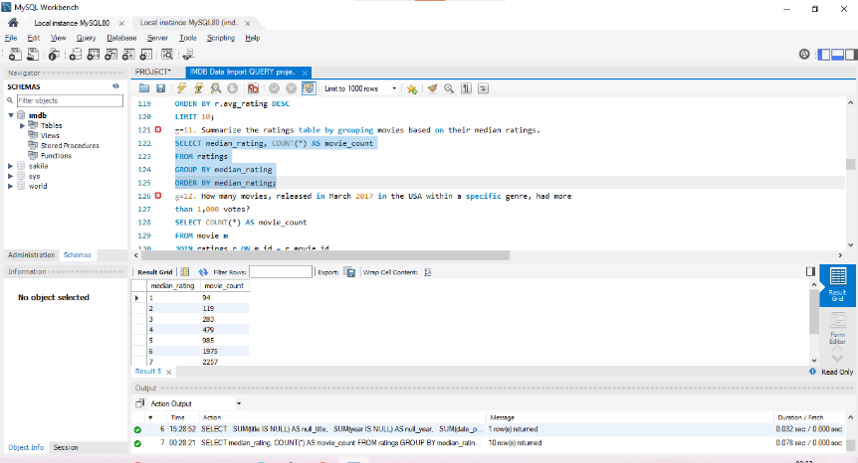

==13. Find movies from each genre that begin with the word “The” and have an average rating
greater than 8.
SELECT g.genre, m.title, r.avg_rating
FROM movie m
JOIN ratings r ON m.id = r.movie_id
JOIN genre g ON m.id = g.movie_id
WHERE m.title LIKE 'The %'
AND r.avg_rating > 8
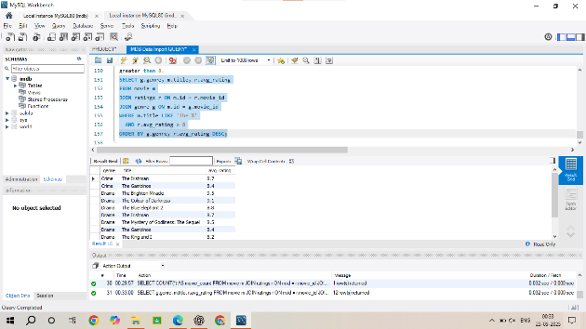
ORDER BY g.genre, r.avg_rating DESC;

==14. Of the movies released between April 1, 2018, and April 1, 2019, how many received a
median rating of 8?
SELECT COUNT(*) AS movie_count
FROM movie m
JOIN ratings r ON m.id = r.movie_id
WHERE m.date_published BETWEEN '2018-04-01' AND '2019-04-01'
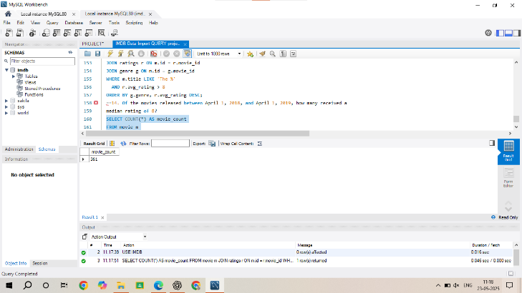
AND r.median_rating = 8;

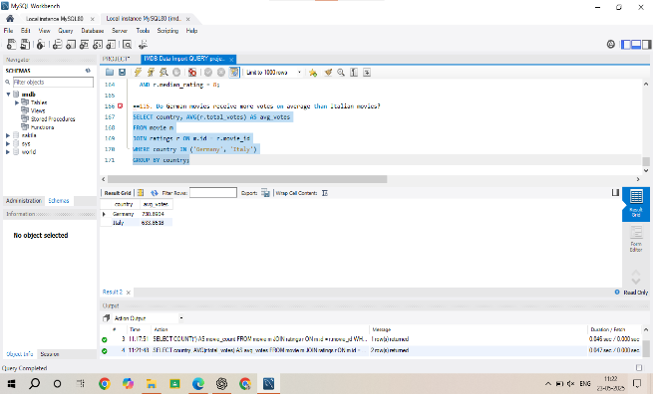
==15. Do German movies receive more votes on average than Italian movies?
SELECT country, AVG(r.total_votes) AS avg_votes
FROM movie m
JOIN ratings r ON m.id = r.movie_id
WHERE country IN ('Germany', 'Italy')
GROUP BY country;

==16. Identify the columns in the names table that contain null values.
select
SUM(CASE WHEN name IS NULL THEN 1 ELSE 0 END) AS null_name,
SUM(CASE WHEN height IS NULL THEN 1 ELSE 0 END) AS null_height,
SUM(CASE WHEN date_of_birth IS NULL THEN 1 ELSE 0 END) AS null_date_of_birth,
SUM(CASE WHEN known_for_movies IS NULL THEN 1 ELSE 0 END) AS null_known_for_movies
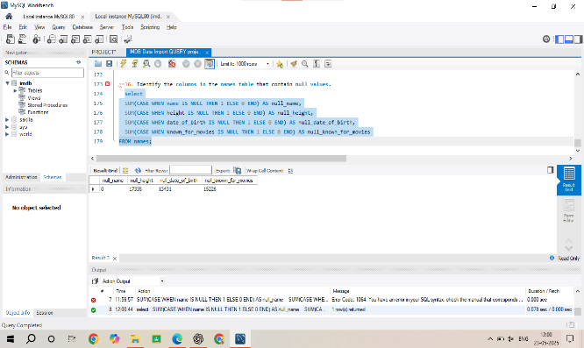
FROM names;

==17. Who are the top two actors whose movies have a median rating of 8 or higher?
SELECT n.name, COUNT(*) AS movie_count
FROM names n
JOIN role_mapping rm ON n.id = rm.name_id
JOIN ratings r ON rm.movie_id = r.movie_id
WHERE rm.category = 'actor'
AND r.median_rating >= 8
GROUP BY n.name
ORDER BY movie_count DESC
LIMIT 2;

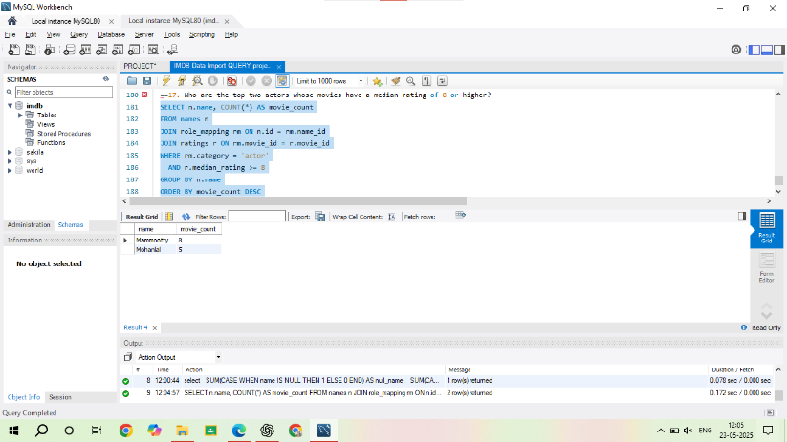

==18. Which are the top three production companies based on the total number of votes their
movies received?
SELECT m.production_company, SUM(r.total_votes) AS total_votes
FROM movie m
JOIN ratings r ON m.id = r.movie_id
WHERE m.production_company IS NOT NULL
GROUP BY m.production_company
ORDER BY total_votes DESC
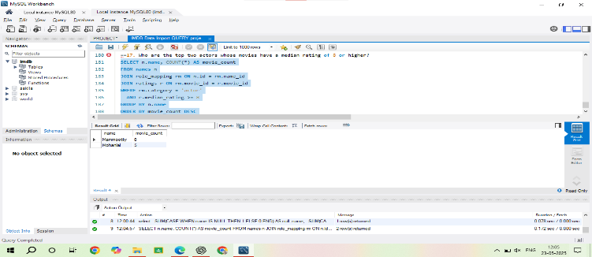
LIMIT 3;

==19. How many directors have worked on more than three movies?
SELECT COUNT(*) AS director_count
FROM (
SELECT name_id
FROM director_mapping
GROUP BY name_id
HAVING COUNT(movie_id) > 3
) AS subquery;
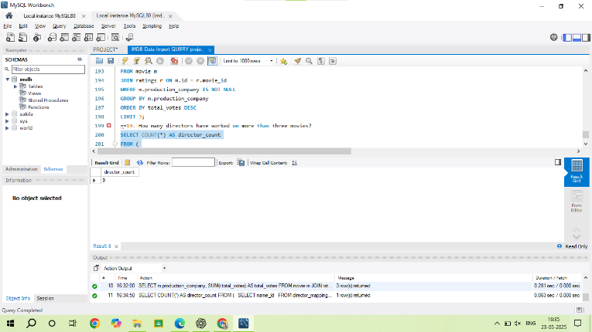

==20. Calculate the average height of actors and actresses separately.
SELECT
category,
AVG(n.height) AS average_height
FROM
role_mapping r
JOIN
names n ON r.name_id = n.id
WHERE
r.category IN ('actor', 'actress')
AND n.height IS NOT NULL
GROUP BY
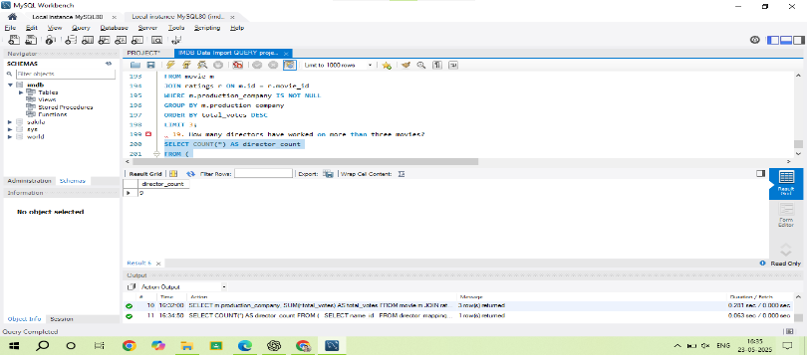
r.category;

21.List the 10 oldest movies in the dataset along with their title, country, and director.
SELECT
m.title,
m.country,
n.name AS director_name,
m.year
FROM
movie m
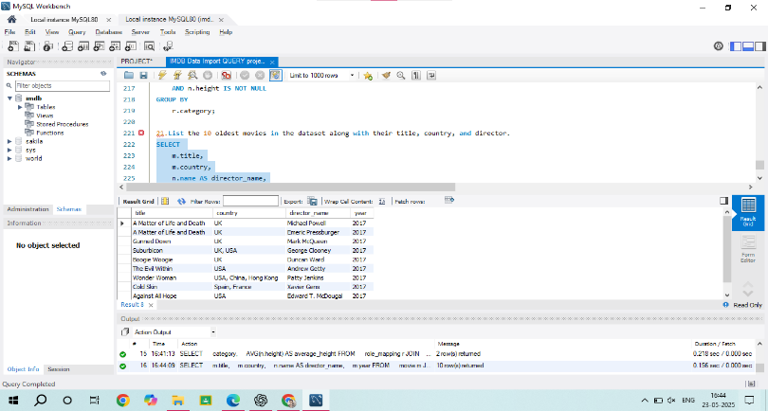
JOIN
director_mapping d ON m.id = d.movie_id
JOIN
names n ON d.name_id = n.id
ORDER BY
m.year ASC
LIMIT 10;

22. List the top 5 movies with the highest total votes, along with their genres.
SELECT
m.title,
GROUP_CONCAT(g.genre SEPARATOR ', ') AS genres,
r.total_votes
FROM
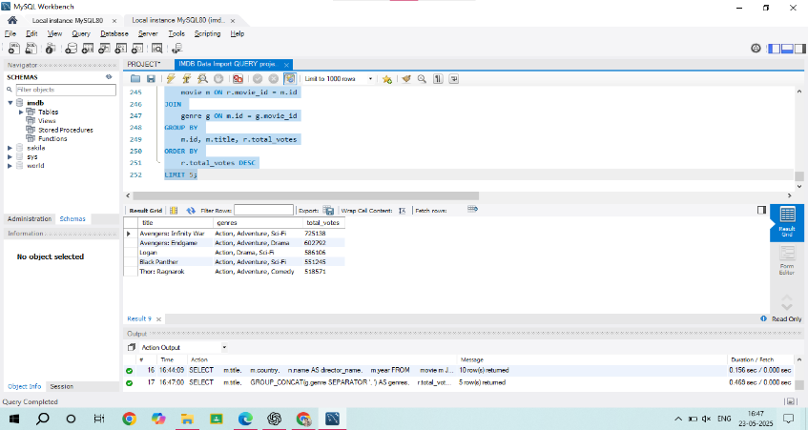
ratings r
JOIN
movie m ON r.movie_id = m.id
JOIN
genre g ON m.id = g.movie_id
GROUP BY
m.id, m.title, r.total_votes
ORDER BY
r.total_votes DESC
LIMIT 5;

==23.Identify the movie with the longest duration, along with its genre and production company.
SELECT
m.title,
m.duration,
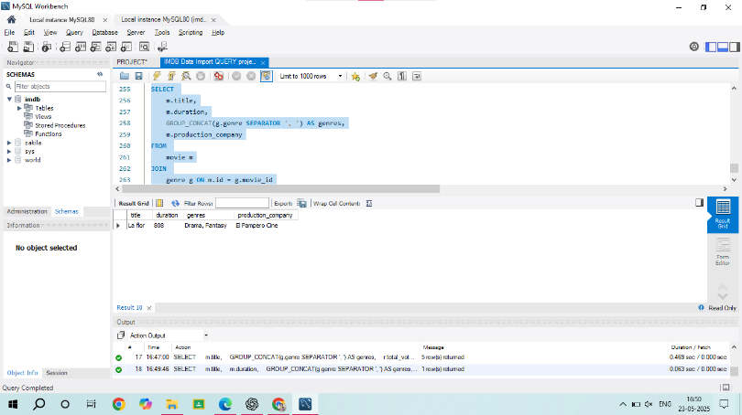
GROUP_CONCAT(g.genre SEPARATOR ', ') AS genres, m.production_company
FROM
movie m
JOIN
genre g ON m.id = g.movie_id
WHERE
m.duration = (
SELECT MAX(duration) FROM movie
)
GROUP BY
m.id, m.title, m.duration, m.production_company;

==24. Determine the total number of votes for each movie released in 2018.
SELECT
m.title,
r.total_votes
FROM
movie m
JOIN
ratings r ON m.id = r.movie_id
WHERE
m.year = 2018;
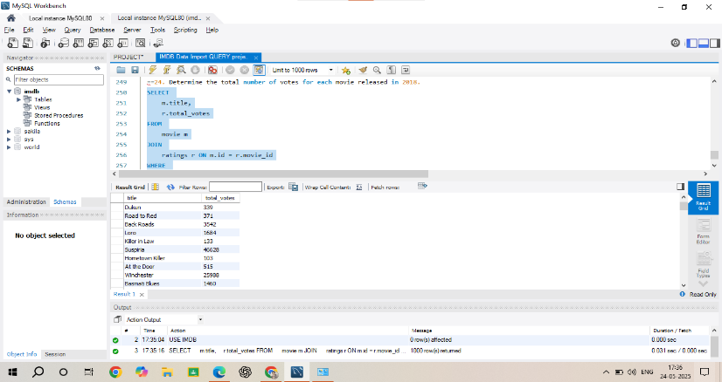

25. What is the most common language in which movies were produced?
SELECT languages, COUNT(*) AS movie_count
FROM movie
GROUP BY languages
ORDER BY movie_count DESC
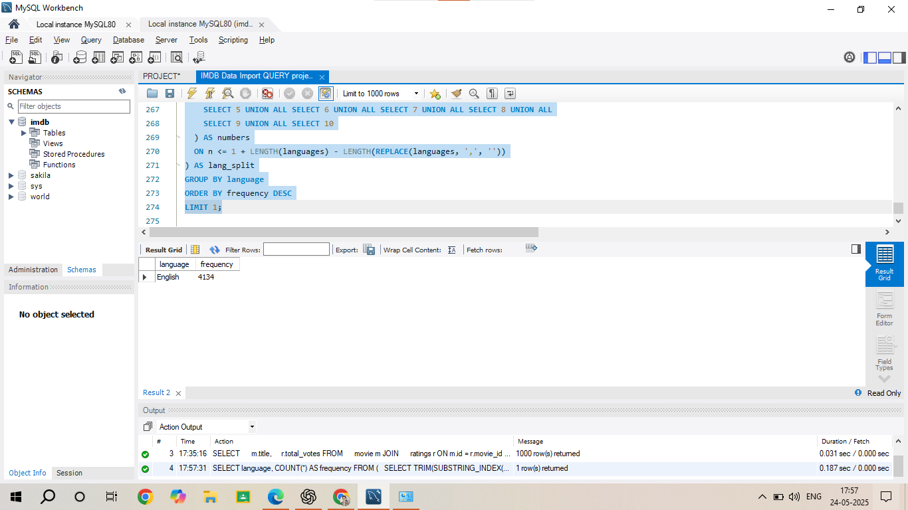
LIMIT 1;

